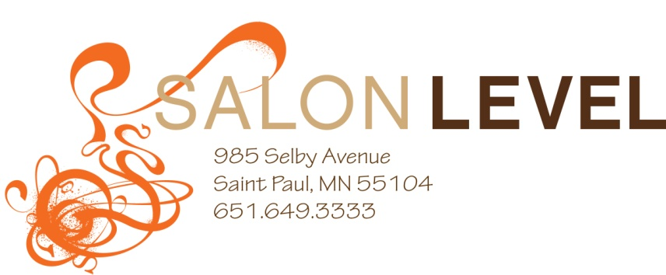
Wedding Contract
Congratulations on your engagement!

Thank you for trusting Salon Level for your special day. We understand all of the planning and hard work that goes into your wedding day. We have the experience to make sure you look and feel your very best on your big day.

Bride’s name_______________________________________
Phone Number_____________________________________
Email______________________________________________
Address___________________________________________
City____________State_________Zip_____________

Wedding day________________________________________
Wedding time______________________________________
Wedding location_____________________________________
Time you need to be ready___________________________
Start time for appointments_____________________________
Hair to be done at salon or off-site______________________
(Off-site fee is an additional $150 charge)

Definitions of services:
Specialty styling is any style with curls and/or putting the hair up.
Shampoo/blow-dry is washing the hair and drying with a round brush.

Bride’s name______________________________________
Specialty styling $80+
Shampoo/blow-dry $50
Make-up (airbrush) $75
Lashes $15

Mother of Bride____________________________________
Specialty styling $80+
Shampoo/blow-dry $50
Make-up (airbrush) $75
Lashes $15

Mother of the Groom________________________________
Specialty styling $80+
Shampoo/blow-dry $50
Make-up (airbrush) $75
Lashes $15

Maid of Honor______________________________________
Specialty styling $80+
Shampoo/blow-dry $50
Make-up (airbrush) $75
Lashes $15

Bridesmaid________________________________________
Specialty styling $80+
Shampoo/blow-dry $50
Make-up (airbrush) $75
Lashes $15

Bridesmaid________________________________________
Specialty styling $80+
Shampoo/blow-dry $50
Make-up (airbrush) $75
Lashes $15

Bridesmaid________________________________________
Specialty styling $80+
Shampoo/blow-dry $50
Make-up (airbrush) $75
Lashes $15

Bridesmaid________________________________________
Specialty styling $80+
Shampoo/blow-dry $50
Make-up (airbrush) $75
Lashes $15

Bridesmaid________________________________________
Specialty styling $80+
Shampoo/blow-dry $50
Make-up (airbrush) $75
Lashes $15

Bridesmaid________________________________________
Specialty styling $80+
Shampoo/blow-dry $50
Make-up (airbrush) $75
Lashes $15

Flower girl________________________________________
Specialty styling $60+
Shampoo/blow-dry $40
Make-up (lip gloss) complimentary

Pre-Styling Hair Maintenance:
If you are doing a specialty style we need you to come with dry, slightly dirty hair. This will ensure your style lasts longer. If you show up with wet hair we will either charge you for drying the hair or we may not be able to complete the service based on the time that was scheduled for you.

Brunch Service:
We can also provide brunch for the wedding party (at salon only) if desired. Brunch will be offered at $15 per person. This brunch includes a variety of bagels, muffins, fruit, cheese, coffee, juice and champagne.

Service total_____________________________
Subtotal_________________________________
Off-site fee______________________________
Brunch total______________________________
Deposit_________________________________
Grand total_______________________________

* Salon Level requires a credit card to reserve all appointments.
* A non- refundable deposit of 50% is required at contract signing.
* The balance due will be processed the day of services.
* 20% gratuity will be added to all bridal services.
* All members of your bridal party must arrive 15 minutes prior to their scheduled appointment.
* Salon Level will not take late arrivals or refund pre-paid services under any circumstance.
* All appointments will be scheduled the day the wedding agreement is filled out and signed.

I have read, understand and agree to the terms of this contract.
Deposit payment by credit card or cash is due upon submission of this contract.

Signature__________________________________________
Date______________________________________________
Credit card type_____________________________________
Credit Card #_________________________Exp.___________

